Assignment 1
Omar A. Shakir Al-Faiadh¹[201735167]
¹ UAE University, UAE
Abstract. In this assignment, Online retail sales price dataset was used for some marketing analytics. The data acquisition and characteristics were explained in the first part of this report. In the second part of the report, some pivot tables and pivot charts were applied and used to acquire insights about the data. Lastly, this report gives some recommendations based on insights to enhance the marketing techniques and strategies.

Keywords: Online Retail, Marketing Analytics, Pivot Tables, Pivot Charts, UK.
- About Data
  - Data acquisition process
The data was collected from an online retail company based in the UK. The dataset shows all purchases made in that online retail company during 8 months. The data was released on Kaggle by Vijaykumar Ummadisetty.

  - Characteristics of the data
The dataset contains 910 records and 8 attributes (columns). These are the 8 different attributes that we have in this dataset:
-InvoiceNo:
Type: Categorical
Description: it is a unique identifier of each transaction. It has 25,900 unique values, no missing values, no mismatches. "573585" is the most common InvoiceNo.

-StockCode:
Type: Categorical
Description: it is a code or a number that represents or identifies the purchased items. There are 4,070 unique values, no missing values, and no mismatched values. "85123A" is the most common value in StockCode.

-Description:
Type: Categorical
Description: it shows a description of the purchased item. There is 4,224 unique values, 1,454 missing values, and no mismatched values. "WHITE HANGING HEART T-LIGHT HOLDER" is the most common value in Description.

-Quantity:
Type: Numerical
Description: it shows how many units was purchased in each transaction. Values range from -80,995 to 81,000. The mean is 9.55 and the standard deviation is 218.

-InvoiceDate:
Type: Date and Time
Description: it shows the date and time of he transaction. The InvoiceDate ranges from "1Dec10" to "9Dec11", which means from 1st of December 2010 to 9th of December 2011. There is no missing value, and no mismatched values.

-UnitPrice:
Type: Numerical
Description: it shows the price per unit of each item. This attribute ranges from -11,100 to 39,000. The mean is 4.61 and the standard deviation is 96.8.

-CustomerID:
Type: Categorical
Description: it shows a unique ID or number of each customer. There are 407,000 valid values, 135,00 missing values, and no mismatched values. It ranges from 12,300 to 18,300.

-Country:
Type: Categorical
Description: it shows the country of the customer. There are 38 unique values. The Uak is the most common value, where there is 91% of purchases were from the UK. There is no missing values and no mismatched values.

- Insights of The Analytics
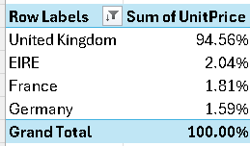
Fig.1.a. Pivot Table of Top 4 Countries Based on The Percentage of The Total Unit Prices.

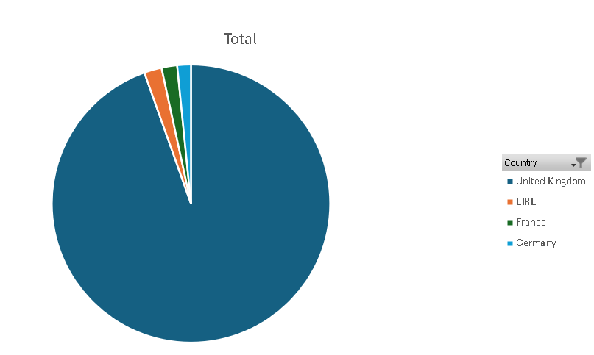
Fig.1.b. Pie Chart of Top 4 Countries Based on The Percentage of The Total Unit Prices.
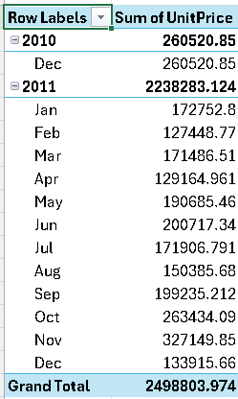
Fig.2.a. Pivot Table of The InvoiceDate Based on The Sum of The Unit Prices.

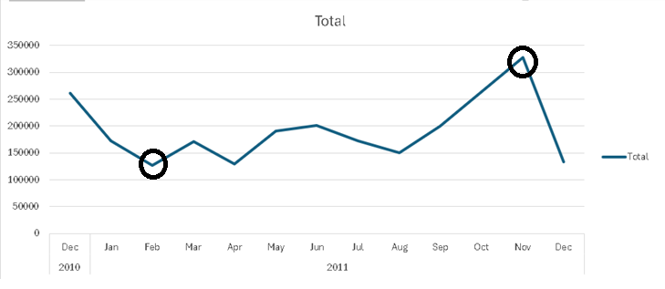
Fig.2.b. Line Chart of The InvoiceDate Based on The Sum of The Unit Prices.

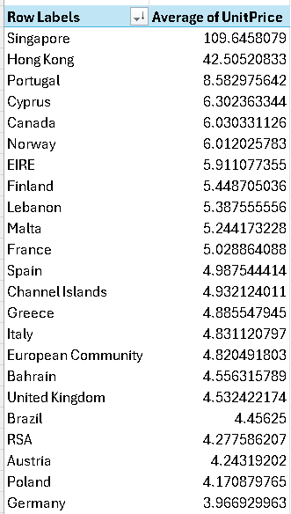
Fig.3.a. Pivot Table of The Top Countries Based on The Average of The Unit Prices.

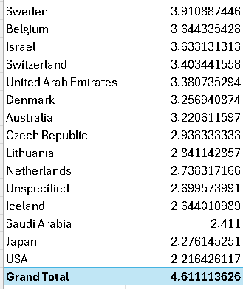
Fig.3.b. Pivot Table of The Top Countries Based on The Average of The Unit Prices.
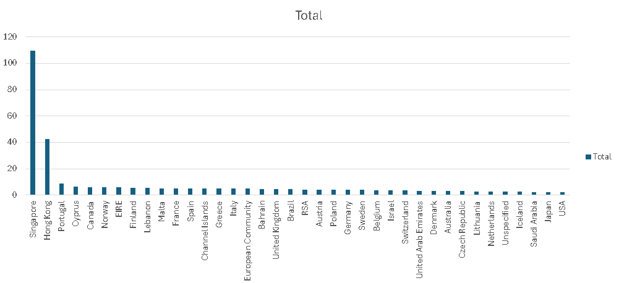
Fig.3.c. Column Chart of The Top Countries Based on The Average of The Unit Prices.
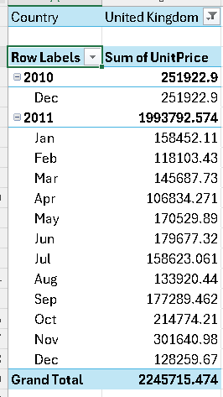
Fig.4.a. Pivot Table of The InvoiceDate in UK Based on The Sum of The Unit Prices.

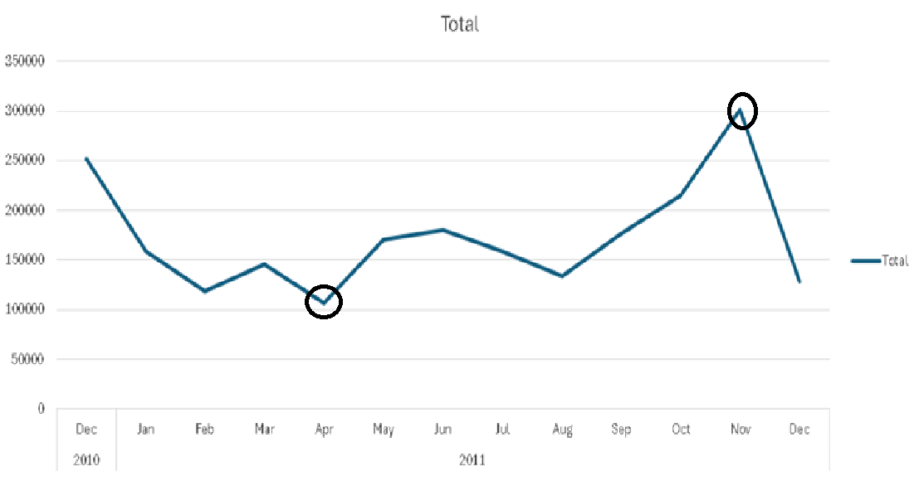
Fig.4.b. Line Chart of The InvoiceDate in UK Based on The Sum of The Unit Prices.

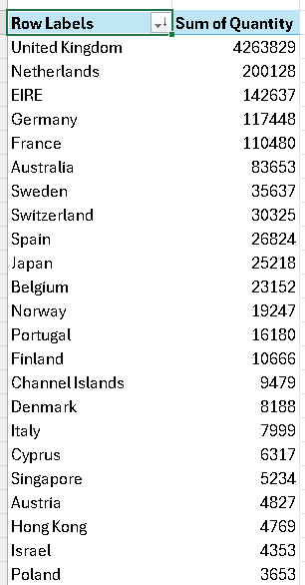
Fig.5.a. Pivot Table of The Top Countries Based on The Sum of Quantities.

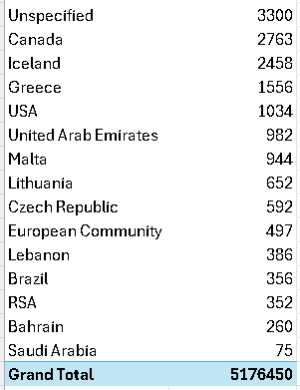
Fig.5.b. Pivot Table of The Top Countries Based on The Sum of Quantities.
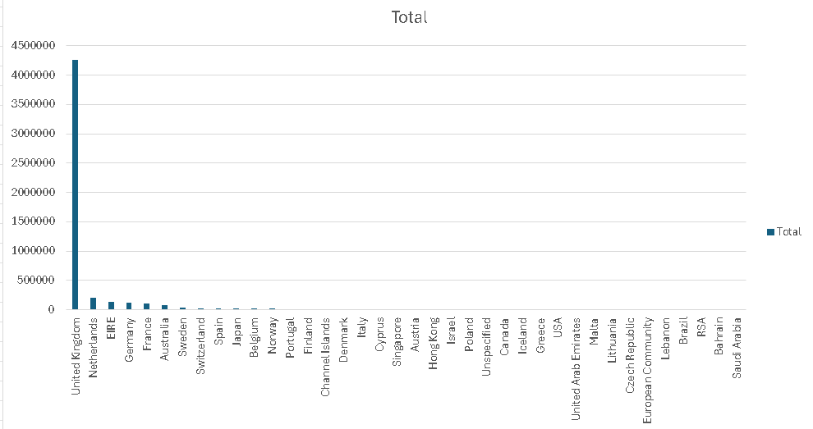
Fig.5.c. Column Chart of The Top Countries Based on The Sum of Quantities.

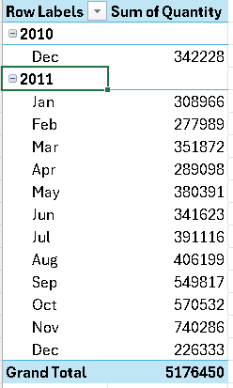
Fig.6.a. Pivot Table of The InvoiceDate Based on The Sum of Quantities.
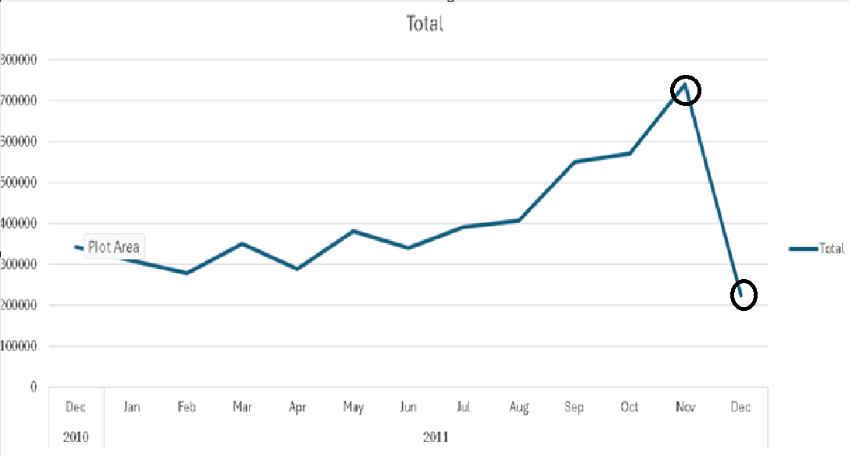
Fig.6.b. Line Chart of The InvoiceDate Based on The Sum of Quantities.

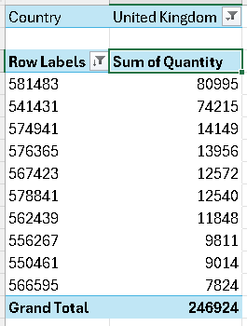
Fig.7.a. Pivot Table of The Top 10 InvoiceNo in UK Based on The Sum of Quantities.

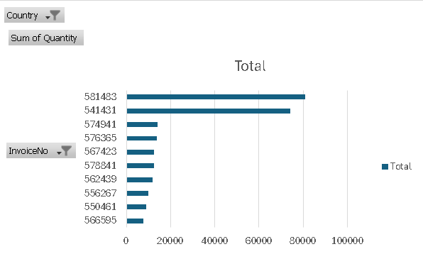
Fig.7.b. Bar Chart of The Top 10 InvoiceNo in UK Based on The Sum of Quantities.
Figure 1.a shows a pivot table of the top 4 countries based on the percentage of the total unit price. Figure 1.b shows a pie chart that visualizes the results of the pivot table (figure 1.a). I have chosen the pie chart because it shows the percentage in an appealing and easy-to-understand way. Figures 1.a and 1.b show that the UK has the highest percentage of total unit price among the top 4 countries, which is 94.56%. This is, as we can see in figure 1.b, is the majority of the grand total unit price. The second highest country based on the total unit price is EIRE with 2.04% of the top 4 countries’ grand total. There is a huge difference in the percentage between the first (UK) and the second (EIRE), which shows that UK is the country that most of the company’s profit and sells come from. Third comes France with 1.81%of the grand total unit profit of the top 4 countries. Fourth comes Germany with 1.59% of the grand total unit profit of the top 4 countries.

The pivot table In Figure 2.a shows how much is the total unit price within each month of 2 years, starting from December 2010 to December 2011 (total of 13 months). Figure 2.b shows a line chart that visualizes the pivot table of Figure 2.a. Line chart is a good option to visualize this pivot table because we have a continuous variable (time) and it show us the change of total unit price over this time (grouped as months and years). The line chart also shows the trends and when the total unit price increase/decrease. The line chart shows seasonality. As we can see in Figure 2.b, the total unit price decreased from December 2010 to February 2011. In February 2011, the total unit price reaches the lowest record of the total unit price over the 13 months. From February 2011 to August 2011, the total unit price start increasing and decreasing without a major change or specific pattern. In September 2011, the total unit price starts to increase almost constantly up until November 2011, where it reached a peak of 327,149.85 total unit price, which is the highest total unit price over the 13 months. We can see the almost straight increasing line from August 2011 to November 2011 that show that people start increasingly buy more of this online retail. The increase of total unit price stops in November 2011, where in December 2011, the total unit price drops sharply into 133,915.66 total unit price (it dropped more than half of the total unit price of November 2011).

The pivot table in Figure 3.a and 3.b show the ranking of countries based on the average of the unit price on the online retail. Figure 3.c shows a column chart that visualizes the ranking of the countries with the highest average of unit price to the lowest from left to right. As we can see in these figures, people in Singapore have the highest average of unit price among all other countries, which means that people in Singapore tend to buy much more expensive items than people from other countries with an average unit price of 109.65. Second comes Hong Kong with an average unit price of 42.51, which is more than half of Singapore’s average unit price. As we can see in Figure 3.c, there is a big gap in the average of unit price between these two countries and the rest of the world, where third comes Portugal with an average unit price of 8.58, which is less than quarter of Hong Kong’s average unit price. The most important insights that we can get from this pivot table are that people in Singapore and Hong Kong buy much more expensive things than the rest of the world and the ranking of to” countries based on the average unit price. We can see that UK has one of the lowest averages of unit price comparing to the rest of the world, even though they had the highest total unit price in the first pivot table. This show that the total unit price in UK is high because of the huge number of transactions, not how much expensive/cheap are the items. We can go later into more details about the Quantity within each transaction based on the country to show this point clearer.

The pivot table In Figure 4.a shows the total unit price in UK within each month of 2 years, starting from December 2010 to December 2011 (total of 13 months). Figure 4.b shows a line chart that visualizes the pivot table of Figure 4.a. Line chart is a good choice to visualize this pivot table because we have a continuous variable (time) and it show us the change of total unit price in UK over this time (grouped as months and years). The line chart also shows the trends and when the total unit price increase/decreases in UK. The line chart shows seasonality. As we can see in Figure 2.b, the total unit price in UK decreased from December 2010 to February 2011. From February 2011 to August 2011, the total unit price in UK start increasing and decreasing without a major change or specific pattern. In April 2011, the total unit price in UK reaches the lowest record of the total unit price over the 13 months. In September 2011, the total unit price in UK start to increase almost constantly up until November 2011, where it reached a peak of 301,640.98 total unit price in UK, which is the highest total unit price in UK over the 13 months. The increasing of total unit price in UK stops at November 2011, where in December 2011, the total unit price drops sharply into 128,259.67 total unit price in UK (it dropped more than half of the total unit price in UK of November 2011). The similarity between Figure 4.b and Figure 2.b show that UK is truly the country with the major impact on the total unit price as the pie chart in Figure 1.b showed us earlier.

The pivot table In Figure 5.a and 5.b show the total quantity of units bought from each country. The column chart in Figure 5.c visualized the results of this pivot table from the country with the highest total quantity at left to the country with the lowest total quantity at right. The column chart shows that UK has the highest total quantity of units bought, where it had a total of 4,263,829 units bought. And after a huge difference, Netherlands comes as the second highest country with a total of 200,128 units bought. Then, EIRE, Germany, and France come as third, fourth and fifth, respectively, where they almost had a similar total quantity that ranged from 110,480 to 142,637. The grand total quantity of units bought from all over the world was 5,176,450 units.

The pivot table In Figure 6.a shows the total quantity of units bought in each month of 2 years, where we start with December 2010 to December 2011 (total of 13 months). The line chart in Figure 6.b visualizes the pivot table. As we can see, the sum of quantities from December 2010 to July 2011 don't have an increasing or decreasing pattern, where it was increasing then decreasing then increasing and so on. From July 2011 to November 2011, the sum of quantities was increasing until it reached a peak of 740,286 quantities in November 2011, which is the highest amount of sum of quantity at it is shown in Figure 6.b. Then, in December 2011, the sum of quantities drops into the lowest amount of sum of quantities within the period of December 2010 to December 2011, where in December 2011 it dropped to 226,333 quantities (which is the lowest at it is shown in Figure 6.b).

The pivot table in Figure 7.a shows the ranking of the top 10 Invoice Numbers based on their total quantity (number of units bought). The bar chart in Figure 7.b shows this pivot table where it shows the Invoice Number with the highest quantity at the top while the Invoice Number with the lowest quantity at the bottom. As we can see, 581483 had the highest sum of quantity in UK with a total of 80995, at second comes 541431 with a total of 74215, and then comes 574941 with a total of 14149 quantity.

References
- Kaggle, https://www.kaggle.com/datasets/vijayuv/onlineretail?resource=download, last accessed2024/11/5.
- ChatGPT, https://chatgpt.com/share/6725e426-2d78-8002-8906-e6e8fea69a10, last accessed 2024/11/2.

